Project Report

For

**Potholes Categorization and Assistance**

Prepared by

|  |  |  |
| --- | --- | --- |
| **Specialization** | **SAP ID** | **Name** |
| AIML B4(Hons.) | 500086839 | Jitender Dhariwal |



Department of AI School Of Computer Science

UPES

DEHRADUN, Uttarakhand

Mentor By: Cluster Head:

Dr. Ajay Prasad Dr. Anil Kumar

**TABLE OF CONTENT**

|  |  |  |
| --- | --- | --- |
| **S. No.** | **Topic** | **Page no**. |
| 1 | ABSTRACT | 3 |
| 2 | INTRODUCTION | 3 |
| 3 | OBJECTIVE | 3 |
| 4 | LITERATURE REVIEW | 4 |
| 5 | PROBLEM STATEMENT | 4 |
| 6 | EXISTING SYSTEM ISSUE | 4 |
| 7 | PROPOSED SYSTEM DESIGN | 5 |
| 8 | LANGUAGES USED | 5 |
| 9 | UML DIAGRAM | 6 |
| 10 | FLOWCHART | 6 |
| 11 | RESULTS | 7 |
| 12 | CONCLUSION | 8 |
| 13 | FUTURE WORK | 8 |
| 14 | REFERENCES | 8 |

# ABSTRACT

Potholes are serious risks to drivers and their vehicles. This project aims to tackle this issue by developing an automated system utilizing advanced computer vision technologies. The system's primary objective is to detect potholes in road images, determine their quantity, and provide guidance to drivers based on the road condition.

Our system analyzes pictures of roads to identify potholes accurately. It then counts how many potholes appear in these images. But beyond just counting, it goes the extra mile by offering valuable advice to drivers depending on the number of potholes detected. For instance, if there are only a few, it assures the driver to continue safely. However, if there are numerous potholes, it warns the driver to slow down due to the challenging road conditions.

In essence, this system contributes to safer roads by detecting potholes and providing guidance to ensure drivers stay safe. It's an innovative application of technology aimed at enhancing driving experiences and minimizing the issues caused by troublesome potholes.

1. **INTRODUCTION**

Pothole is a problem on roads worldwide, causing vehicular damage, accidents, and traffic disruptions. Recognizing the critical need for preventive measures to reduce the risks associated with potholes, this project endeavors to develop an intelligent solution using technologies. By harnessing the power of deep learning-based object detection, the system aims to detect and categorize potholes from images captured via cameras or other sensors. Additionally, the project includes an assistance mechanism that provides real-time guidance to drivers based on the severity of pothole occurrences detected on the road.

The introduction of this project marks a crucial step toward a safer and more informed driving experience. Through automated pothole detection, quantification, and assistance, this system seeks to contribute to road safety initiatives and minimize the adverse effects of potholes on drivers and vehicles.

1. **OBJECTIVE**

The primary goal of this project is to create an automated system that employs computer vision techniques to:

* Detect potholes accurately within road images.
* Quantify the number of potholes identified in these images.
* Provide guidance to drivers based on the detected road conditions, ensuring safer and more informed driving experiences.

Through this system, we aim to enhance road safety by empowering drivers with timely information about road hazards, specifically targeting potholes, thereby mitigating potential risks and minimizing road-related accidents and vehicle damages.

1. **LITERATURE REVIEW**

The study introduces a smartphone-based solution to categorize and count potholes in India, utilizing YOLO v7 for categorization and Google API plus Accelerometer for counting, providing a cost-effective alternative to existing complex detection methods.[1]. Another research presents a mobile-based pothole detection method using accelerometer data and spatial interpolation, ensuring precise detection without false-positives. Its accuracy and potential for improving traffic safety in Intelligent Transportation Systems (ITS) were demonstrated in experiments.[2] One of the paper introduces a pothole detection system using deep learning models (YOLO V3). After training and testing these models on labeled images, YOLO V3 emerges as the most efficient due to its faster and more reliable detection capabilities.[3] Some researcher explores pothole detection for road safety in Bangladesh, employing image data and ML algorithms like SVM, Logistic Regression. SVM emerged as the most effective, yielding a high accuracy of 99% for detecting potholes.[4]

1. **PROBLEM STATEMENT**

The inefficiency in current pothole detection methods poses risks to road safety and vehicle maintenance. Manual identification and quantification of potholes on roads result in delayed repairs and increased hazards for commuters. This project aims to develop an automated system utilizing computer vision and other techniques to detect, quantify, and assist in pothole identification, mitigating risks and improving road safety.

1. **EXISTING SYSTEM ISSUE**

The existing manual system for detecting and assessing potholes on roads suffers from inefficiencies and delays. Relying on human inspection alone often leads to slow identification and quantification of potholes, causing delays in necessary repairs. Moreover, the subjective nature of manual assessment introduces inconsistencies and inaccuracies, undermining the reliability of road condition evaluations. These shortcomings emphasize the urgent requirement for an automated system that can significantly improve the efficiency, accuracy, and promptness of pothole detection and assessment processes.

1. **PROPOSED SYSTEM DESIGN**

The proposed system design integrates advanced computer vision techniques to create a automated solution for pothole detection, quantification, and real-time assistance.

**Object Detection Model:** Utilizes YOLOv7, a robust object detection algorithm, to identify potholes in road images.

**Pothole Counting Algorithm:** Counts the number of detected potholes in an image, providing an accurate assessment of the road condition.

**Real-time Assistance:** Offers contextual guidance to drivers based on the severity and count of potholes detected.

**Enhanced Road Safety**: Aims to significantly improve road safety by efficiently detecting potholes and assisting drivers in navigating hazardous road conditions.

1. **LANGUAGES AND TECHNOLOGIES USED**

**Python**: Primary language used for the project due to its rich libraries and frameworks

**YOLOv7**: Implemented for object detection due to its efficiency and accuracy in identifying potholes.

**OpenCV**: Utilized for image processing tasks such as reading images, manipulating image data, and drawing bounding boxes around detected potholes.

**Matplotlib**: Employed for data visualization, allowing for the display of images with annotated pothole locations.

**Google collab**: Used for prototyping, experimenting and coding and results in an interactive environment.

**Command Line Tools:** Employed for various tasks like dataset extraction, model training, and testing.

1. **UML DIAGRAM**

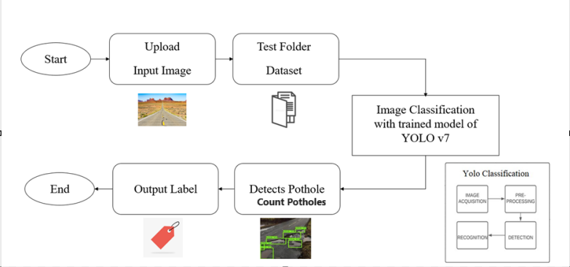

1. **FLOWCHART**

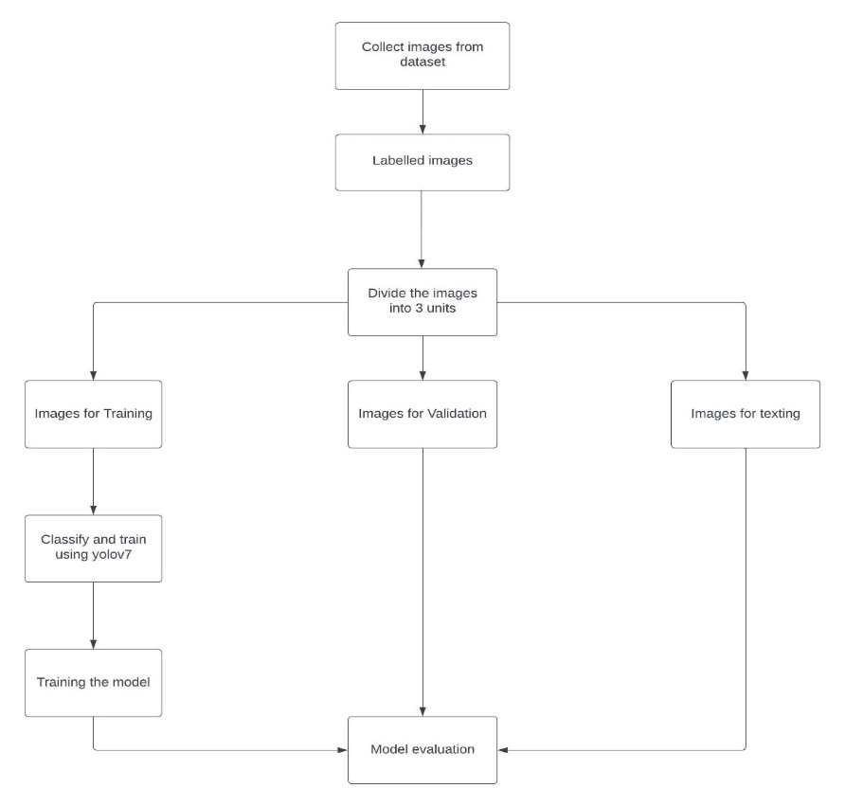

1. **RESULTS**

**Pothole Detection Accuracy:** The YOLOv7 model showcased commendable accuracy in detecting potholes within road images.

**Pothole Counting Precision:** The counting algorithm accurately determined the number of potholes in the detected areas, providing reliable quantification of road hazards.

Potholes detected

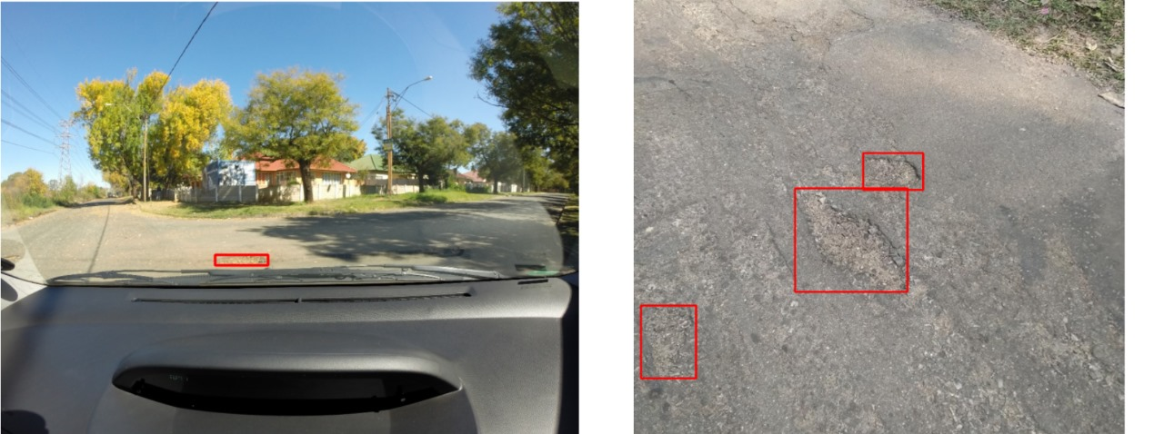

Final result

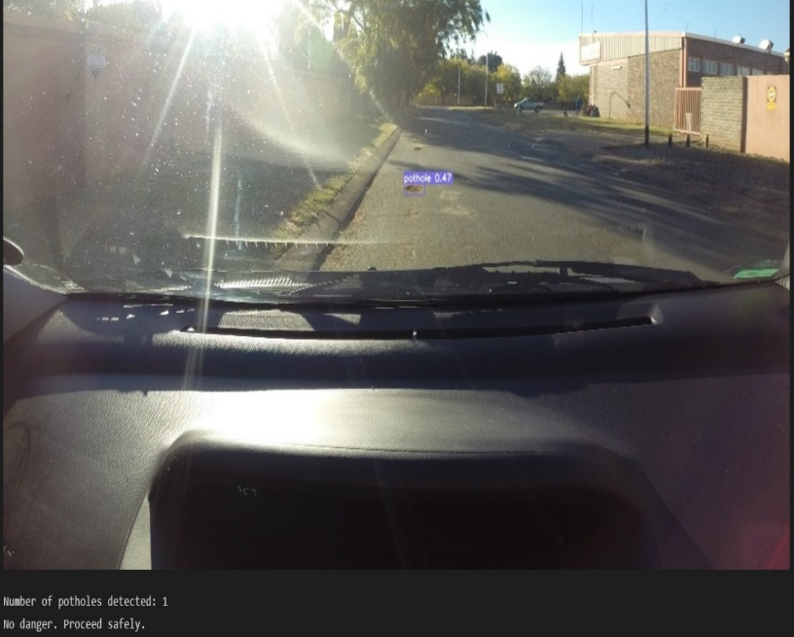

1. **CONCLUSION**

This project introduced an automated system utilizing advanced computer vision with YOLOv7 for precise pothole detection. It accurately counts potholes in road images and provides guidance to drivers, enhancing road safety. The system showcases promising results in detecting hazards and aiding drivers. Future enhancements could focus on real-time integration with vehicle systems and refining accuracy for varied road conditions.

1. **FUTURE SCOPE**

**Real-time Integration**: Enhance the system to integrate directly with vehicles, offering instant alerts or adjustments in driving dynamics based on detected potholes.

**Adaptability to Diverse Conditions**: Improve the model to recognize potholes under diverse environmental conditions like rain, snow, or low light, ensuring consistent accuracy.

**Multimodal Integration**: Explore combining data from other sensors (such as LiDAR or GPS) to enrich the detection system's accuracy and provide more comprehensive guidance.

**Scaling for Urban Infrastructure**: Extend the system to assess and address broader infrastructure issues beyond potholes, contributing to comprehensive road maintenance.

**Mobile Application Development**: Develop a dedicated mobile app allowing users to report potholes, contributing to a comprehensive database and enhancing system accuracy.

**Fleet Management Integration**: Implement this technology into fleet management systems, aiding commercial entities in optimizing routes and ensuring vehicle safety.

1. **References**

*[1] E. S. T. K. Reddy and R. V, "Pothole Detection using CNN and YOLO v7 Algorithm," 2022 6th International Conference on Electronics, Communication and Aerospace Technology, Coimbatore, India, 2022, pp. 1255-1260, doi: 10.1109/ICECA55336.2022.10009324.*

*[2] Wang, Hsiu-Wen & Chen, Chi-Hua & Cheng, Ding-Yuan & Lin, Chun-Hao & Lo, Chi-Chun. (2015). A Real-Time Pothole Detection Approach for Intelligent Transportation System. Mathematical Problems in Engineering. 2015. 1-7. 10.1155/2015/869627*

*[3] P. Ping, X. Yang and Z. Gao, "A Deep Learning Approach for Street Pothole Detection," 2020 IEEE Sixth International Conference on Big Data Computing Service and Applications (BigDataService), Oxford, UK, 2020, pp. 198-204, doi: 10.1109/BigDataService49289.2020.00039.*

*[4] A. K. M. Jobayer Al Masud, S. T. Sharin, K. F. T. Shawon and Z. Zaman, "Pothole Detection Using Machine Learning Algorithms," 2021 15th International Conference on Signal Processing and Communication Systems (ICSPCS), Sydney, Australia, 2021, pp. 1-5, doi: 10.1109/ICSPCS53099.2021.9660216.*